WEST LONDON WASTE AUTHORITY
Report of the Treasurer and Managing Director | 22 January 2021
2021/22 Budget

SUMMARY
This report sets out the 2021/22 budget proposal following consultation with boroughs
RECOMMENDATION(S)
The Authority is asked to: -
- Approve the 2021/22 budget
- Approve the Pay As You Throw (PAYT) rates in section 15 and the PAYT levy made up of two components totalling of £52.3 million
- Approve the Fixed Cost Levy (FCL) of £12.8 million in section 16
- Approve the recommended trade/DIY prices in section 17 and delegated authority to the Treasurer to change these in year should the need arise
- Approve the new proposed capital budgets in section 18
- Approve the target level of reserves of £7.4 million to act as a buffer for managing risks and avoiding supplementary levies, in section 19
- Introduction

  - The 2021-22 draft budget was considered at the Authority meeting in December and subsequently shared/presented to meetings of the West London Environment Directors and West London Treasurers. The Finance Directors were also asked to provide a formal response to the budget proposals.
  - The report which follows is almost the same as Decembers’ but updated for:
- The removal of an inflationary salary uplift following the Chancellors announcement in December regarding public sector pay
- The latest 2020-21 forecast in the table in section 2.3
- Formal feedback from borough Finance Directors (section 21 and appendix 2)
  - There are no other changes
  - The Authority is required to levy boroughs by 15 February each year and will if necessary adjust these to incorporate any later approval by boroughs of their final Council Tax Base figures – as these final figures will be used to apportion the fixed cost levy, per borough feedback.
- Executive Summary
  - The focus for the 2021/22 budget is the progressing the WLWA business plan actions including projects across west London and within the Authority. Section 3 provides examples of the wide-ranging work planned and illustrates some of the strategic themes that members will hear more about in the coming years’ Authority meetings.
  - In producing the 2021/22 budget the main challenge was the uncertainty resulting from the pandemic, particularly around forecasting waste volumes. This is by far the biggest driver of the overall movement in budget from the previous year. Therefore this year’s proposal includes sensitivity analyses to reflect the risks in relation to waste forecasting. This also highlights where the strategic opportunities lie and so the reason for the focus on business plan objectives.
  - The table below sets out the 2021/22 budget and the movement from the 2020/21 budget. The latest 2020/21 forecast is also included to provide context and illustrate the current level of activity.
 | 2020-21 budget  £ 000’s | 2020-21 forecast £ 000’s | 2021-22 budget  £ 000’s | Changes in budgets £ 000’s
Costs
WTD - Waste Transport and Disposal | 47,916 | 49,326 | 50,363 | 2,447
MRF Service Costs | 0 | 2,103 | 2,469 | 2,469
Depreciation | 8,778 | 8,790 | 9,240 | 462
Financing Cost | 5,360 | 5,364 | 5,230 | (130)
Premises | 2,607 | 2,642 | 2,620 | 13
Employees | 2,173 | 2,282 | 2,252 | 79
Supplies and Services | 900 | 1,561 | 968 | 68
Revenue Funding of Debt | 920 | 920 | 941 | 21
Concession Accounting Adjustments | (4,296) | (4,296) | (4,382) | (86)
Total costs | 64,358 | 68,692 | 69,701 | 5,343
Income
Levies | 62,273 | 64,016 | 65,119 | 2,846
MRF service income | 0 | 2,103 | 2,469 | 2,469
Other Income | 2,085 | 2,282 | 2,113 | 28
Total income | 64,358 | 68,401 | 69,701 | 5,343
Total (surplus)/deficit | 0 | 291 | 0 | 0
  - The budget headings are per our usual format for regular budget monitoring reports. The most notable movement in spending is for Waste Transport and Disposal, which is reflected in an overall increase in Levies. The MRF activities have a neutral effect with costs being matched by income. Plans for the coming year and an explanation of all budget items follows.
- Business Plan Focus

  - The Authority’s Business Plan identifies action in 3 areas; Climate Emergency, Joint Working and Data. The budget for 2021/22 aims to push on with some of this strategic work and the table below illustrates just some of the project work for the coming year.

Project | Indicative Benefit / Savings Opportunity | Any borough feedback required
£3m Food Waste Initiative | £5 million | Is there anything boroughs can do to move these forwards faster?
Collection Methodology | £12 million | What do boroughs need in order to start long term planning?
Routing of Collection Services | £0.075 million | Local project in progress
Bin Sensors | £0.075 million | Projects in progress
HRRC Projects | £0.4 million | Projects in progress
Waste Minimisation | Education | Projects in progress
Weekly Waste Reporting and Data Hub | Data driven decisions | Projects in progress
Climate Emergency Action Plan and WLWA Carbon Reduction Plan | Environmental | Projects in progress

  - Progressing and delivering these projects will help boroughs and the Authority to be well placed for the implications of the Resource and Waste Strategy and be well informed for any decision making with good quality data and information both at a holistic and operational level.
- Waste Transport & Disposal (WTD)

  - The WTD budget accounts for the majority of the entire WLWA budget and makes up 72% of the overall spend (67% of the entire spend is residual waste). Given that the vast majority of non WTD spend is largely depreciation, financing etc, then strategically residual waste is where most of the significant savings opportunities can be found.

  - The 2021/22 WTD budget is £50.3 million, an increase of £2.4m principally reflecting the higher overall forecast volumes of waste.
  - The residual waste budget is the key driver and represents 93% of the WTD costs (or two thirds of all Authority costs – hence the strategic significance). For 2021/22 this is based on boroughs’ forecasts of collected residual waste plus Authority forecasts for HRRC waste.
  - Borough forecasts for collected waste are 6.8% greater than the 2020/21 budget and reflect the current volumes disposed continuing throughout next year.
  - It should be noted that we will fine tune tonnages with boroughs for the final Authority paper in January, but in overall terms numbers are not expected to change materially.
  - For HRRC waste, Authority forecasts are 1.4% lower than the 2020/21 budget and reflect the current volumes of waste. Authority forecasts have been used for HRRC waste because most borough forecasts were understated, effectively replicating this year’s April and May site closures.
  - The table below provides an indication of the risk underlying tonnage forecasts.
Borough collected waste | Impact on costs (£000s)
5% lower residual tonnage | (2,710)
2% lower residual tonnage | (1,084)
1% lower residual tonnage | (542)
Base case – 21/22 budget | 0
1% higher residual tonnage | 542
2% higher residual tonnage | 1,084
5% higher residual tonnage | 2,710
  - The above table also illustrates the scale of opportunity for boroughs.
  - Given that food waste processing is very significantly cheaper per tonne than residual waste disposal, the borough food waste projects will also deliver significant savings. The following table summarises the cost savings from borough food waste projects and some sensitivities.
Borough | Target food tonnes to extract from residual | Cost savings £000s | £000s impact of +/- 1% tonnes achieved | £000s impact of +/- 2% tonnes achieved | £000s impact of +/- 5% tonnes achieved
Brent | 8,700 | 835 | 8.4 | 16.7 | 41.8
Ealing | 10,100 | 970 | 9.7 | 19.4 | 48.5
Harrow | 7,500 | 720 | 7.2 | 14.4 | 36.0
Hounslow | 6,000 | 576 | 5.8 | 11.5 | 28.8
Hillingdon | 8,600 | 464 | 4.6 | 9.3 | 23.2
Richmond | 11,600 | 1,114 | 11.1 | 22.3 | 55.7
Total | 52,500 | 5,040 | 50.4 | 100.8 | 252.0
In addition to these cost savings there are fundamental environmental benefits including the carbon impact which should not be overlooked.
  - Looking at the complete picture, the 2021/22 budgeted tonnage is made up of the following materials:
Material | 2020/21 Total Tonnes | 2021/22 Total Tonnes | Change
Residual | 420,405 | 444,814 | 24,409
Mixed organic | 17,000 | 857 | (16,143)
Green | 43,663 | 54,127 | 10,464
Wood | 22,400 | 15,256 | (7,144)
Kitchen | 31,068 | 39,747 | 8,679
Other | 11,907 | 7,816 | (4,091)
Budgeted tonnages | 546,443 | 562,617 | 16,174
  - The movement between years includes the impact of service changes where boroughs have identified them. E.g. a move from a mixed organics collection to separate kitchen and green collections. Cautiously no other borough forecasts include the impact of the food waste projects.
  - RPIX of 2.1% (an average of published forecasts including HM Treasury) has also been applied to prices where there is a contractual indexation requirement. Note that within the main PPP contract this impact is mitigated by the pricing mechanism which dampens the overall effect of inflation.
  - The budget assumes market rates apply for any additional waste above the 390,000 tonnes capacity secured in long term contracts. Given the competitive overall price achieved in these long term arrangements, this further emphasises the need to focus on reducing residual waste volumes.
- Depreciation

  - The budget for 2021/22 of £9.2 million is £0.4 million higher than in 2020/21. This principally reflects property asset valuations and indexation agreed with auditors for the latest audited accounts.
  - The largest element of depreciation relates to the SERC (Severnside Energy Recovery Centre) and totals 8.0 million. It should be noted that for depreciation calculations, the SERC has to be separated out into its main components and each key component has to be depreciated over its own expected life.
  - Depreciation for the remaining assets have been calculated using the audited accounts and subsequent change in the asset registers (i.e. additions and disposals).
- Financing

  - The financing costs reflects the interest paid on loans. These have reduced from £5.3 million in 2020/21 to £5.2 million for 2021/22 primarily as a result of the payment profile of repayment loans. With repayment loans a fixed sum is paid every year comprising of both interest and principal repayment. The interest element will continue to fall over coming years, conversely the principal repayment will rise.
  - The largest component of financing costs relates to borrowing from boroughs for the construction of the SERC and totals £4.7 million. The loans are at arm’s length and from a borrowing perspective the boroughs are like any other lender with the loan agreements specifying the relationship with the Authority and including a rate of interest of 7.604%.
  - The interest on loans for the purchase of transfer station freeholds makes up the balance of £0.6 million and represents a PWLB loan at 2.24%.
- Premises
  - The budget for 2021/22 of £2.6 million is almost the same as the budget in 2020/21.
  - The largest component of the premises costs are business rates which account for £2.4 million of this budget of which SERC rates make up £1.5 million and transfer stations £0.8 million.
- Employees
  - The 2021/22 budget of £2.3 million is £0.1 million higher than the 2020/21 level. This covers growth for a wide range of employee costs including an increase in the establishment, wage inflation and training which are partly offset by savings from reduced pension costs resulting from the latest valuation.
  - The 2021/22 establishment is planned to increase by 1.9 to 38.3 full time equivalent (FTE) posts including growth and minor re-alignment of staffing resource to focus on the business plan objectives (e.g. food, data and projects as highlighted in section 3) and deliver increasing volume of ongoing activity resulting from the transition of projects into business as usual.
  - The growth and realignment is good value internal resource for Boroughs and will deliver much of the project management, data analysis, management Information and financial due diligence in relation to the business plan projects. With the large number of projects commenced and in the pipeline this is a better option than each project acquiring its own (i.e consultancy) financial and data/MI resource and will ensure knowledge is retained within the business so it can be used in the transition of work into business as usual
  - A breakdown of the establishment by area of activity is provided below:
Activity | 2020/21 | 2021/22 | Change
Contract Management | 3.6 | 4.0 | 0.4
Corporate Services | 7.2 | 8.7 | 1.5
Operations (Abbey Road) | 15.6 | 14.6 | (1.0)
Projects | 3.0 | 4.0 | 1.0
Waste Minimisation | 7.0 | 7.0 | 0.0
Total | 36.4 | 38.3 | 1.9
  - Putting this into context the Authority employed 88 FTE in 2012/13 (with many in-house services), 42 FTE in 2014/15 and over the last few years FTE numbers have been just above the mid 30’s. The size of the staffing establishment numbers remains stable and small whilst providing the resource to drive forwards business plan objectives and undertake the increasing volume, variety and complexity of work.
  - It is worth noting that pension valuations and contributions have historically bounced up and down. So as the next valuation is due in 2022/23 the coming years work will consider options including the benefit of additional lump sum payments etc. to improve the predictability of pension spends.
- Supplies & Services
  - The 2021/22 budget for Supplies & Services is £1.0 million and is £0.1 million more than the 2020/21 level.
  - A wide variety of spends make up this total, the most notable being insurances, waste minimisation activities and borough services (e.g. committee services, treasury etc.).
  - Pricing inflation has been offset by managers’ efficiencies and stripping out/reducing unused 2020/21 budgets.
- Revenue Funding of Debt
  - The loan which financed the purchase of the transfer station sites is a typical repayment loan. It is made up of two components – an element for the interest on the loan (see Financing Costs) and an element repaying the loan principal.
  - The Revenue Funding of Debt is the element repaying the sites loan and totals £0.9 million for 2021/22. This is marginally higher (£20,000) than 2020/21 reflecting that within a typical repayment loan, the amount of principal repaid increases over time and amount of interest falls.
  - It is worth providing the following brief recap of the revenue funding of debt which was detailed in Authority papers recommending the site purchase a number of years ago.
  - It is a requirement for public bodies to ultimately fund the cost of assets through levies and taxes. For the Authority this is achieved through a combination of the depreciation charge and revenue funding of debt.
  - Typically the acquisition of assets result in an annual depreciation charge. This annual expenditure is recovered through the levy mechanism and therefore the levies over the life of the asset fund its purchase.
  - However, the acquisition of the sites freehold is essentially a purchase of land. For land, accounting rules do not allow a depreciation charge. This means that in order to fund the purchase through levies a different (but comparable to depreciation) annual charge is made – the revenue funding of debt.
- Concession Accounting Adjustments
  - Essentially under a PPP arrangement a contractor pays for the construction of an asset and then recovers its investment over a long period through its operational charges to the local authority (i.e. its price per tonne).
  - There are very specific and detailed accounting requirements that govern this type of arrangement. This is because the underlying nature of this transaction is that the local authority essentially owns the asset for a period of time and the contractor is essentially a lender financing the construction of the asset.
  - The key feature of the accounting is the calculation of a concession accounting adjustment to separate out the disposal and financing costs, followed by stripping out from expenditure a notional sum for the repayment of any underlying borrowing by the contractor.
  - The concession accounting adjustments over the term of the contract were agreed with the auditors EY. For 2021/22 they total £4.4 million, compared to £4.3 million in 2020/21. This accounting adjustment reduces overall costs and levies by £0.1 million.
- Growth and Savings
  - The majority of Authority spending is committed under long term contracts (e.g. PPP) or agreements (e.g. loans) or governed by accounting requirements (e.g. depreciation). This leaves less opportunity for savings.
  - However, as part of the budget setting process at an operational level, a variety of measures have ensured savings across areas where managers are able to exercise some control. This included budget managers reporting their 2021/22 plans and proposed savings to a budget challenge session with the Chair and Chief Officers.
  - The tables below identify the growth and savings which are included within the 2021/22 draft budget. The tables separate out real growth and savings from other movements reflecting longer term decisions.
  - Summary table:
 | £ 000’s
Budgeted costs/levies 2020/21 | 62,273
Growth | 4,059
Savings | (1,480)
Other movements | 267
Budgeted costs/levies 2021/22 | 65,119
  - Growth table:
Area | Explanation | Growth  £ 000’s
Waste Transport and Disposal | Increased residual tonnages and pricing inflation (£3.661k), range of other smaller price and tonnage movements (£87k) | 3,748
Premises | Increased cleaning costs (£16k) and cost of water supply (15k) | 31
Employees | Growth in establishment (102k) salary increments (£7k), team realignments (£86k) and other minor items (£17k) | 212
Supplies and Services | Increased health and safety advice (£51k) and other minor items (£17k) | 68
 |  | 4,059
  - Savings table:
Area | Explanation | Saving  £ 000’s
Waste Transport and Disposal | Savings from lower quantities of wood (£410), mattresses (£154k), inert waste (£209k), reduced transport costs (£64k) and switch from mixed organics to separate collections (£464k) | (1,301)
Premises | Range of minor cost savings | (18)
Employees | Reduced pension costs | (133)
Other Income | Range of minor improvements | (28)
 |  | (1,480)
  - Other movements table:
Area | Explanation | Increase / (Decrease) £ 000’s
Depreciation | Reflecting property valuations agreed with auditors for the last accounts | 462
Financing Costs | Reflecting reducing interest in repayment loans for SERC with boroughs | (130)
Revenue Funding of Debt | Reflecting rising repayment of principal in repayment loans for sites with PWLB | 21
Concession Accounting Adjustment | Reflecting adjustments agreed with auditors for the last accounts | (86)
 |  | 267
- PAYT / FCL split
13.1 PAYT costs relate to waste that boroughs collect and deliver to transfer stations and FCL costs are those which relate to waste from HRRC sites and the Authority’s running expenses.
13.2 The PAYT also includes an element for the recovery of SERC financing costs, depreciation, rates and concession accounting adjustments etc.
13.3 The breakdown of the budget between PAYT and FCL activities is as follows:
PAYT (disposal cost) | 2020/21  £000’s | 2021/22  £000’s | Change  £000’s
Waste Transport and Disposal | 40,661 | 43,871 | 3,210
PAYT Levy (disposal) | (40,661) | (43,871) | (3,210)
Total | 0 | 0 | 0

PAYT (SERC cost) | 2020/21  £000’s | 2021/22  £000’s | Change  £000’s
Depreciation (SERC) | 6,486 | 6,889 | 403
Financing Costs (SERC) | 4,103 | 4,078 | (25)
Premises (SERC) | 1,225 | 1,247 | 22
Concession Accounting Adjustment (SERC) | (3,645) | (3,772) | (127)
PAYT Levy (SERC) | (8,169) | (8,442) | (273)
Total | 0 | 0 | 0

FCL | 2020/21  £000’s | 2021/22  £000’s | Change  £000’s
Waste Transport and Disposal | 7,255 | 6,492 | (763)
Employees | 2,173 | 2,252 | 79
Premises | 1,382 | 1,373 | (9)
Supplies and Services | 900 | 968 | 68
Depreciation | 2,292 | 2,351 | 59
Financing | 1,257 | 1,152 | (105)
Revenue funding of Debt | 920 | 941 | 21
Concession Accounting Adjustment | (651) | (610) | 41
Non Levy Income | (2,085) | (2,113) | (28)
FCL Levy | (13,443) | (12,806) | 637
Total | 0 | 0 | 0

13.4 Note the PAYT has been split to show its two main components.
- Levy Setting
  - The levy to boroughs is made up of 3 parts
- PAYT (disposal) – Rates (£/tonne) for different materials which reflect the average prices paid to contractors, charged to boroughs initially on the basis of budgeted tonnes but then reconciled and adjusted (with rebate/charge) at the end of each quarter to reflect the actual tonnages.
- PAYT (SERC) – this is the apportioned recharge of SERC costs. The cost is initially apportioned and charged on the basis of budgeted tonnes then at the end of every quarter recalculated using the actual tonnage with any adjustment being rebated/charged to the borough.
- FCL (fixed) – this is the recharge for all other costs (i.e. HRRC, overheads etc) on the basis of boroughs tax base from their final approved CTB1 returns.
The only minor change to this year’s levy setting is in relation to apportioning the FCL. Following feedback from boroughs during the 2020/21 budget exercise the final borough approved Council Tax base will be used instead of the provisional October figure. This final published figure was felt by most boroughs to be a more accurate method for apportioning the fixed costs.
Details of these follow in the next two sections.
- PAYT Levy Income
  - As identified above the PAYT is made up of two components and therefore the PAYT levy is too. Combined the PAYT levy will total £52.3 million (from the table above £43,871 plus £8,442).
  - The table below shows the proposed disposal rates for waste in 2021/22.
Material (Disposal) | 2020/21 £ per tonne | 2021/22 £ per tonne
Residual | 102.46 | 104.91
Gully | 54.43 | 55.93
Food | 10.35 | 10.92
Green | 29.16 | 29.09
Mixed food and green | 49.50 | 50.45
Wood | 42.84 | 42.37
Rubble | 45.93 | 45.19
Soil | 45.95 | 45.95
Gypsum | 93.93 | 93.93
Mattresses (per mattress) | 4.55 | 4.41
  - In addition to this, the Authority manages non-household waste from HRRC sites and incurs transport costs. On a similar basis the average transport charges for 2021/22 are provided below.
Material (Transport) | 2020/21 £ per tonne | 2021/22 £ per tonne
Residual (collected) | 8.18 | 8.34
Other recyclables (collected) | 12.11 | 10.93
  - These rates represent the average cost to the Authority for the disposal and transport of materials. They reflect the blended price paid to a number of contractors.
  - These rates will be applied to the 2021/22 tonnage forecasts from boroughs and result in a monthly charge to them. Each quarter end a reconciliation exercise will take place to adjust for the actual amount of waste that each borough delivers, so boroughs only pay for the volume of waste actually disposed.
  - Using tonnage forecasts from boroughs, the PAYT charges for 2021/22 are as follows:
Borough | 2020/21 PAYT disposal charge £000’s | 2021/22 PAYT disposal charge £000’s | Increase  £000’s
Brent | 7,311 | 7,928 | 617
Ealing | 8,391 | 8,775 | 384
Harrow | 5,345 | 6,108 | 763
Hillingdon | 8,658 | 8,002 | (656)
Hounslow | 6,322 | 7,657 | 1,335
Richmond | 4,634 | 5,401 | 767
Total | 40,661 | 43,871 | 3,210
  - It is worth noting that the above levies use borough forecasts for the volumes of waste, including any implications from service changes. The borough’s PAYT tonnage forecasts for residual waste, the largest component of PAYT, are provided below:
Borough | 2020/21 budgeted tonnage | 2021/22 budgeted tonnage | Growth  tonnage
Brent | 69,659 | 73,980 | 4,321
Ealing | 80,061 | 81,141 | 1,080
Harrow | 48,619 | 54,898 | 6,279
Hillingdon | 70,489 | 67,552 | (2,937)
Hounslow | 59,060 | 69,732 | 10,672
Richmond | 42,845 | 48,544 | 5,699
Total | 370,733 | 395,847 | 25,114

  - It is worth repeating that should borough waste volumes be higher or lower than forecast, then each quarter they will be charged or refunded a sum to ensure they pay only for what is actually delivered.
  - The second, PAYT (SERC) component relates to the £8.4 million SERC cost, equivalent to £21.47 per tonne (2020/21: £22.20). This will initially be apportioned and levied on the basis of 2021/22 budgeted residual waste tonnages excluding gully waste. A quarterly exercise will then adjust this sum to reflect the actual residual tonnages delivered that quarter with a reimbursement or additional charge. The initial apportioned annual charge is summarised below.
Borough | 2020/21 PAYT SERC charge £000’s | 2021/22 PAYT SERC charge £000’s | Growth  £000’s
Brent | 1,527 | 1,568 | 41
Ealing | 1,771 | 1,733 | (38)
Harrow | 1,080 | 1,178 | 98
Hillingdon | 1,564 | 1,450 | (114)
Hounslow | 1,281 | 1,473 | 192
Richmond | 946 | 1,040 | 94
Total | 8,169 | 8,442 | 273
16. FCL Income
  - The FCL charge primarily relates to the costs of managing the treatment and disposal of household waste delivered to HRRC sites. It also includes the Authority’s administration and nets off other income. These costs are apportioned to the boroughs.
  - The apportionment calculation initially uses provisional Council Tax base figures provided by the boroughs. However, when charging, the FCL costs will be apportioned using the final borough approved Council Tax base, per feedback from boroughs. Borough Council Tax base figures may not all be published in time for the January Authority meeting and therefore the FCL charges will be finalised before the start of the new year.
  - On this basis the draft FCL (fixed) charge is as follows:
Borough | 2020/21 FCL charge £000’s | Provisional 2021/22 Council Tax base | 2021/22 FCL charge £000’s | Change £000’s
Brent | 2,214 | 98,176 | 2,205 | (9)
Ealing | 2,740 | 104,520 | 2,348 | (392)
Harrow | 2,054 | 89,044 | 2,000 | (54)
Hillingdon | 2,333 | 101,038 | 2,269 | (64)
Hounslow | 2,024 | 87,775 | 1,971 | (53)
Richmond | 2,078 | 89,612 | 2,013 | (65)
Total | 13,443 | 570,165 | 12,806 | (637)
  - The FCL (fixed) sum will not change over the course of the year. The Authority bears any loss or surplus resulting from overspend or underspend.
17. Other Income

  - The 2021/22 budget is £2.1 million, which is a little better than 2020/21. An increase in trade waste income is the main growth item resulting in this improvement.
  - The majority of the income is from trade waste (£1.5 million) and the proposed main trade/DIY charges per tonne at Abbey Road are provided below. Note that charges are being introduced for difficult to treat and handle materials:
Type of waste | 2020/21 £ | 2021/22 £
Trade waste residual and wood | 160.00 for account customers and £165.00 for others | 160.00 for account customers and £165.00 for others
Trade waste recycling | 80.00 | 80.00
Asbestos (Households only) | 272.00 | 272.00
Mattresses (per mattress) | 10.00 | 15.00
Bulky items | 218.00 | 218.00
Gas bottles from commercial sources | N/A | 5.00
Fire extinguishers from commercial sources | N/A | 5.00
Fridges from commercial sources | N/A | 40.00
  - Further charges may be introduced during the year in response to market conditions and where appropriate in consultation with LB Brent. It is recommended that delegated authority be given to the Treasurer to change charges in year should the need arise.
  - Other income includes an agency fee which passes on the costs of running the Abbey Road HRRC to the local borough. This is being maintained at current levels.
18. Capital

  - The new capital budget requirements for 2021/22 are listed below:
- CCTV, Fire and Automatic Number Plate Reading technology for Abbey Road (£130,000)
- Solar Panels at Abbey Road (£36,000)
- New mobile plant at Abbey Road for sorting bulky waste (£40,000)
- Victoria Road bulking Shed (additional £1,000,000) – increase bulking and sorting capacity to enhance and localise material value and reduce whole system bulking costs. A full business case will be reported for approval in due course.
- New weighbridge software (£20,000)
- Textile/Nappy collection facilities (£10,000)
  - The capital budgets represent infrastructure requirements to deliver ongoing services (CCTV, plant, weighbridge) and also new initiatives providing better value (e.g. less carbon, increased recycling) for the Authority (solar panel, bulking shed, textile facility). Business cases will be made to appropriate decision making body (e.g. Authority, SMT etc) according to the level of investment/savings.
  - It is worth noting the following existing capital budgets. These are balances remaining on budgets for capital works still in progress/to be commenced, which were previously approved by the Authority and will be rolled forward until completion or eliminated if not required.
- Resurface of access roads at Transport Avenue and Victoria Road (£290,000)
- Construction of a bulking facility at Victoria Road (£1.0 million)
- Abbey Road improvements (£371,000)

- Reserves
  - Reserves represent an organisations net worth. They provide a buffer for an organisation to manage risks, for example the fluctuations in the level of activity or costs – these variances in costs lead to surpluses and deficits being absorbed within reserves. On this basis, the Authority’s approach to reserves has been to build up sufficient reserves to act as a buffer against risk.
  - The added benefit of reserves is that they can be used to stabilise pricing by removing the need for “in year” price reviews. For boroughs and indeed the Authority, this pricing stability / predictability facilitates better planning and budgetary control.
  - For 2021/22 the proposal for reserves is cautious given the uncertainties resulting from the pandemic and Brexit.
  - So other than the £3 million already set aside for borough food waste projects no further disbursement is proposed.
  - So considering reserves in overall terms, identifying known risks facing an Authority provides a useful basis for determining a suitable level of reserves for managing risk. The specific risks and potential costs and likelihood that could be associated with them are as follows:
Risk Description | Mitigations | Likelihood | Financial Risk (£000’s)
The budget is based on assumptions of indexation/ inflation, particularly in relation to contracts. There is a risk of higher costs due to higher than anticipated indexation/inflation particularly given uncertainties of Brexit and its impact on the waste markets | Use of reputable forecasts e.g. HM Treasury | Medium | £2,500 (representing approx. 5% of WTD costs)
Whilst the contractor bears most of the risk in the event of the loss/closure of a transfer station, in major events like this there is a possibility of unforeseen additional costs in implementing and operating alternative arrangements. Therefore it would be prudent to set aside something for these uncertainties. | Contract terms, contractor business continuity plans and contingency arrangements, insurances | Low | £1,300  (representing 2 weeks of residual waste disruption in our biggest contract)
An extremely challenging insurance market for the waste sector leading to increased premiums where costs are borne by the Authority | Gradually building reserves to self insure activities where possible | Medium | £1,200  (representing 50% rise in premiums given previous experience of 35%)
Borough FCL tonnages are higher than budgeted resulting in an under-recovery of HRRC disposal costs through the FCL charge which is fixed | Using data and working closely with borough colleagues to try and forecast tonnages accurately | High | £1,000 (based on residual FCL tonnages at 20% in excess of budgeted levels)
Risks / costs will arise from the complex PPP contract as a result of terms that are unclear or ambiguous in relation to the day to day operation and running of services. | Team and professional advisors with experience and knowledge of detailed contract terms | Medium | £700 (based on previous experience of contractual issues)
From time to time, a new market will emerge for recycling of specific waste streams (as opposed to landfill) e.g. carpets. The Authority tests and uses these markets cautiously, however these new markets carry a risk of both market and supplier failure. Should this arise there will be additional costs in making new arrangements to redirect and dispose of waste. | Principally a range of requirements under the procurement rules including competitive procurement, credit checks, scrutiny at various levels including Authority meetings | High | £300  (based previous experience with mattresses and carpets markets)
With a large number of competitors ready to receive trade waste, there is a risk that price competition could lead to a reduction in planned trade and DIY income despite more competitive pricing | Ongoing monitoring of trade income and market place | Medium | £400 (representing 25% of trade income
Target level for reserves |  |  | £7,400
  - The target level of reserves for 2021/22 of £7.4 million compares to £5.1 million in 2020/21 and reflects an emphasis on the volatile waste volumes due to the pandemic, financial risks relating to the economic climate (inflation, Brexit) and ensuring business continuity.
  - Ultimately, the level of reserves is a judgment based on the nature of risk facing an organisation and its risk appetite. On the basis of the risks identified above and appreciating that there are unknown risks which could materialise, the proposed level represents a prudent and not overly cautious target for reserves.
  - The forecast reserve position for the year ending 31 March 2021 is:
 | £000s
Reserves available to manage risks 31 March 2020 per accounts | 11,048
Forecast deficit for 2020/21 per period 9 budget monitoring report | (291)
Set aside for borough food waste projects | (3,000)
Forecast position for 31 March 2020 | 7,757
  - Provided that no risks materialise and something close to the £7.8 million forecast position is achieved for 2020/21, the Authority will be above its target level of by £0.4 million. However it is prudent to retain all reserves until the very significant current uncertainties of post pandemic outlook and post brexit position are clarified and the reserve position will be reviewed accordingly.
- Medium and Long Term Plan
  - The plan has been updated to incorporate the proposed budget and uses base assumptions of 0.5% for the annual growth in residual tonnages and RPIX of 2.1%. The key outputs can be found in Appendix 1 and this shows a healthy financial position. The assumptions are then flexed to identify the key factors effecting the Authority’s finances. This identifies the residual waste tonnages movement as the key strategic factor determining the growth in costs and levies. To a much lesser extent inflation is also an important factor.
  - The key messages from the plan are consistent with last year and are positive.
- The volume of residual waste is the key driver of spend/levies so should be a key area of strategic focus
- The effect of inflation is dampened by the PPP contract
- The Authority will be debt free at the end of the plan and will maintain healthy cash balances to manage any liquidity risk
- Borough Responses to Budget Consultation
  - The formal borough responses to the 2021/22 budget proposals from borough Finance Directors can be found in appendix 2. 5 responses were received. There were no common themes (i.e. raised by 3 or more boroughs) this year to respond to within this report.
- Financial Implications
  - These are included in the report.
  - It is a statutory requirement for the Authority to set a balanced budget (Local Government Finance Act 1992) and to set the levy for constituent boroughs by 15 February (Joint Waste Disposal Authorities (Levies) Regulations 2006).
- Legal Implications
22.1 The are no legal implications of this report
Contact Officers | Jay Patel, Head of Finance 01895 54 55 11  jaypatel@westlondonwaste.gov.uk  Ian O’Donnell, Treasurer  ianodonnell@westlondonwaste.gov.uk  Emma Beal, Managing Director 01895 54 55 15  emmabeal@westlondonwaste.gov.uk

Appendix 1
Outputs
Using the proposed budget and base assumptions, the medium and long term financial model then gives us some outputs, for example, how our costs (and consequently levies to boroughs) change over time, or how our loan balance changes over time. The main outputs are provided below and illustrate that effecting residual waste tonnages is the key.

Tonnage – The chart below illustrates the impact of the base assumption of 0.5% annual growth in residual tonnage. Over the life of the plan, the residual tonnage rises from 444,814 to 493,930 tonnes, although the impact of this growth could be mitigated by all boroughs implementing plans to increase the capture of food waste.

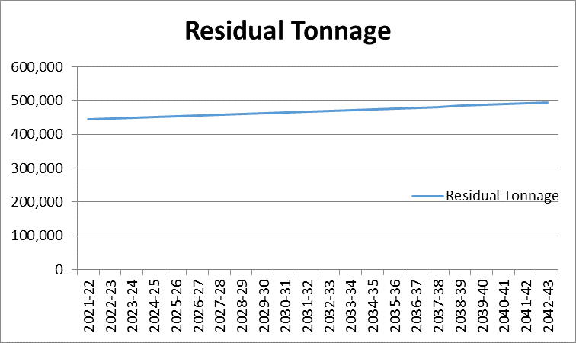

Overall expenditure – This equates to the total levies charged to boroughs and the chart below has been split to show the PAYT and FCL as well as the total. The chart illustrates the growth in overall expenditure and levies over time.

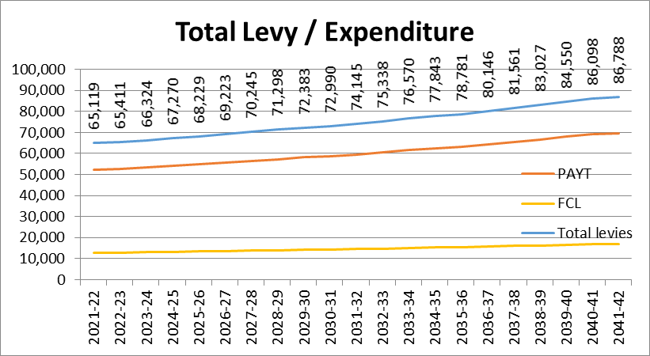

This chart above illustrates an average annual growth of 1.4% over the long-term which is significantly lower than the 2.6% underlying growth from general contract inflation RPIX (2.1%) and annual growth in tonnages (0.5%).

This growth is contained as a result of the way the PPP contract is structured. The contract is for up to 300,000 tonnes of waste with the first 235,000 tonnes having pricing uplifts essentially capped at up to 1.5%. This significantly dampens the effect of inflation over the whole life of the contract.

It should be noted that projects like the MRF procurement and HRRC services have a net nil/neutral effect as costs and revenues will be passed on to relevant boroughs directly.

The dampened growth in costs and levies is further illustrated in the medium term in the chart below.
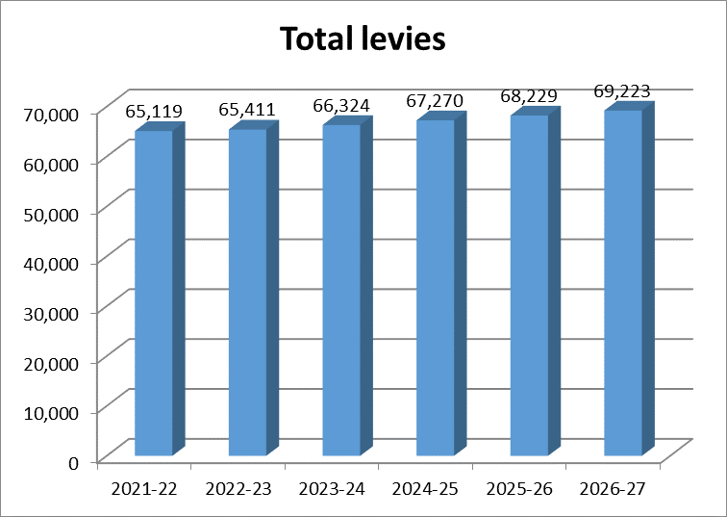

The table above shows an average growth in levies of 1.2% per year over the next 5 years. Boroughs may want to consider using this as an estimate of the increase in the WLWA levies within their medium term financial plans.

The chart below shows how the current medium term plan compares to the plan reported last year and this shows a consistent picture.

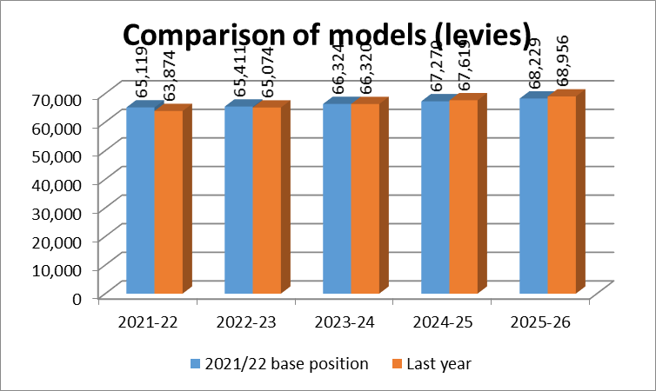

Debt / long-term liabilities and cash – The following chart illustrates the movement in the debt / long-term liabilities as they are paid / settled. The repayments commence at a low level and progress at increasingly larger sums, resulting in the debt/long term liability curve. This effect is reflected in the cash balances which build up in early years when repayments are small and fall in later years when loan repayments are large.

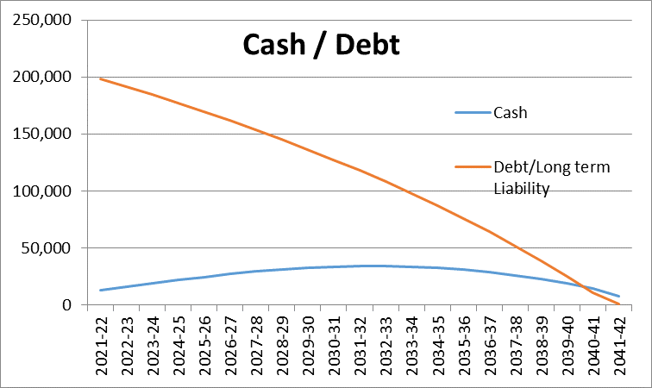

At the end of the plan, the Authority will be debt free.
Sensitivity Analysis
The table below illustrates the impact on growth of costs/levies of differing assumptions for the key business driver, the residual tonnage growth with underlying price inflation remaining at 2.1%.
Residual waste growth assumption | Average rise in costs / levies over 5 years | Average rise in costs / levies over life of plan
-5% | -3% | -4.8%
-2% | -0.7% | -1.3%
-1% | 0.1% | -0.2%
0% | 0.8% | 0.9%
0.5% base | 1.2% | 1.4%
1% | 1.6% | 2.0%
2% | 2.4% | 3%
This illustrate the impact that could be achieved by even small reductions in long term residual waste growth – a 1% reduction in waste would more than offset the long term inflationary increases and result in falling costs/levies.
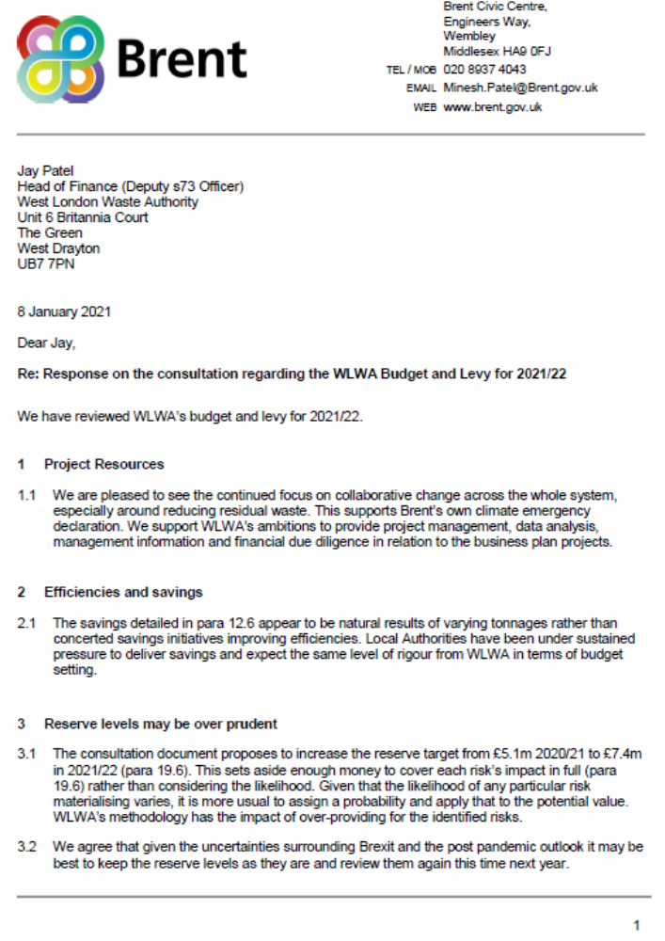

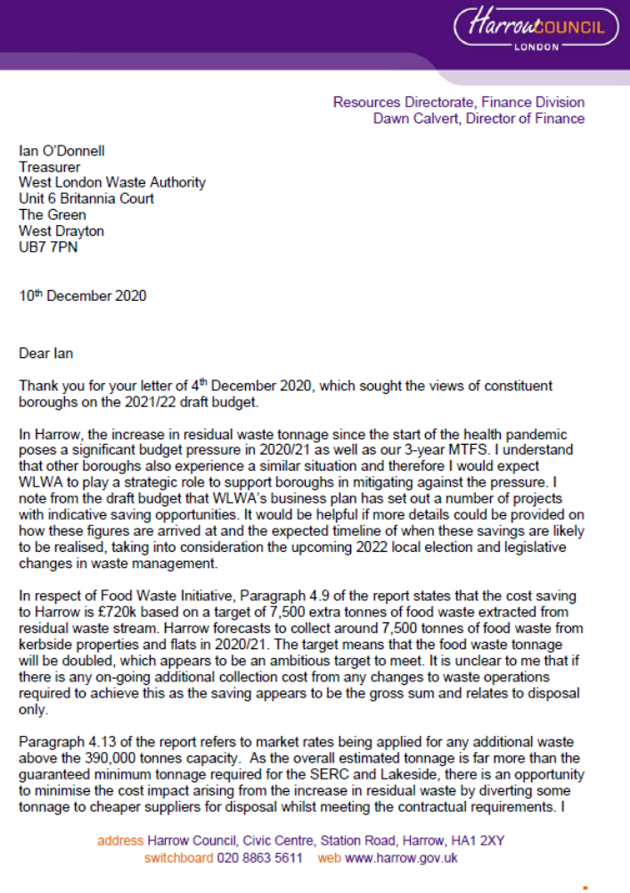
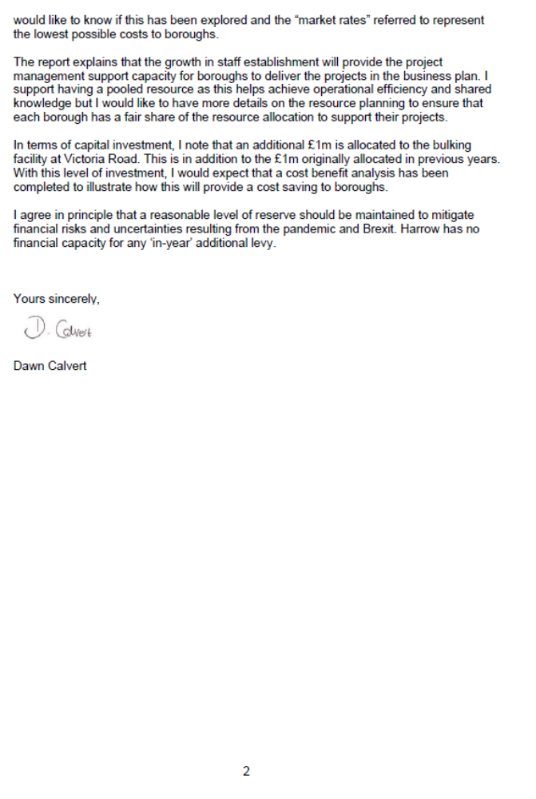
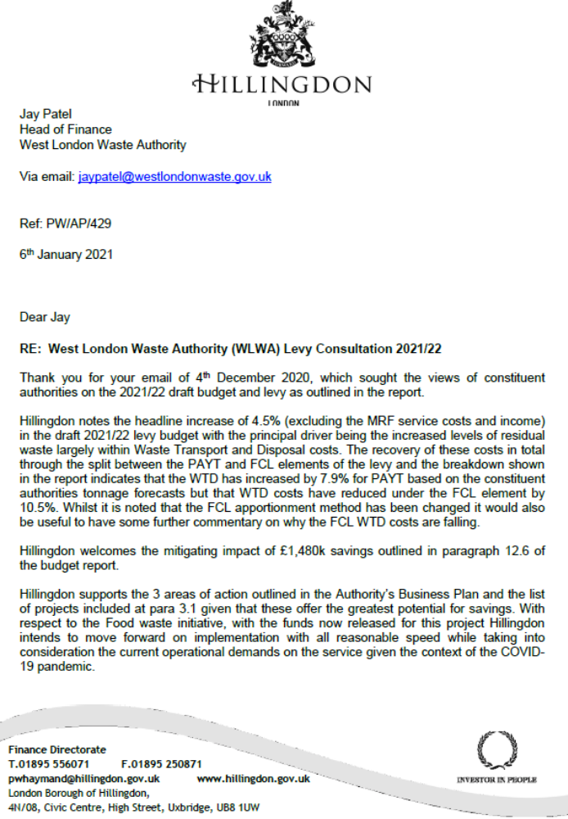
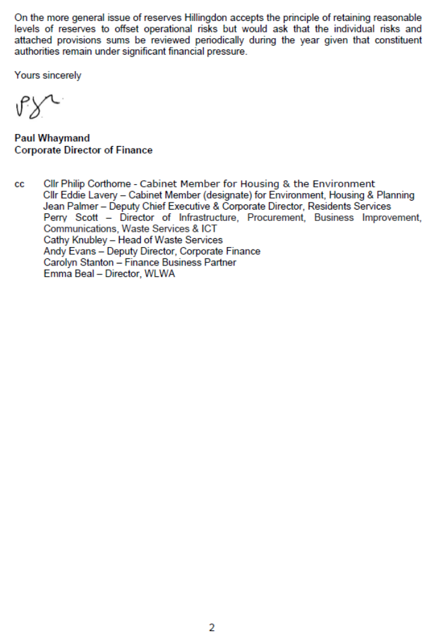
LB Hounslow


